
PROJECT WORK : Guidelines

- Project Based Learning is the application of the comprehensive methodology to inculcate the spirit of strategizing industry operations in a real-time environment.

- The project work aims to foster students with an opportunity to develop conceptual, analytical, communication and interpersonal skills.

Selection of Project work Topic


The choice of topic for the project work and the approach to be adopted needs to be based on the field of specialization.
It is important to distinguish between ‘project work topic’ and ‘project work title’. The topic is the specific area that you wish to investigate. The title may not be decided until the project work has been written so as to reflect its content properly.

The project topic should conform to the following:
Relevant to business or technology, defined broadly;
Related to one or more of the subjects or areas of study within the core program and specialization;
Clearly focused so as to facilitate in-depth study, subject to the availability of adequate sources of information and to your own knowledge;

Of value and interest to you and your personal and professional development.

Planning the Project work
Selecting an original and relevant topic for investigation.
Establishing the precise focus of your study by deciding on the aims and objectives of the project work, formulating questions to be investigated, deciding the sampling techniques and statistical techniques to sum up the findings of the study. Consider very carefully what is worth investigating and its feasibility.

Drawing up initial project work outlines considering the aims and objectives of the project work. Workout various stages of project work

Important instructions and information on Project Submission:

The title of the project should not be more than 12 words in length. The complete Project Work should be submitted in 15000-30000 words. You are supposed to submit project work along with an extended abstract and project guide resume simultaneously.

You must be careful about Originality and Relevance of Project Topic to avoid Project Rejection at a later stage. Therefore, you are required to submit a plagiarism report acknowledging 85% originality
Project Guide must be Post Graduate with a minimum of 10 years of work experience Ensure to include signed & scanned copies of following essential certificates
From Project Guide: Certifying bonafides of project work carried out under his/her supervision
From a student: Certifying that submitted project work is an original piece of work and has not been submitted earlier

You will receive an intimation through a registered email address, on successful uploading of project work report
Viva Questions will be accessible after uploading Project Work.
Project submission will be accepted only after the Project file is uploaded and Viva questions are answered Generally, it takes four to six weeks to complete the process of evaluation of project work.

Writing the Project Work:

  - The abstract for 500-1000 words
An abstract is an overview or a brief summary of project work, which helps the reader to ascertain the purpose of carrying the project work. It acts as a stand-alone entity for the complete project work.
  - The study hypotheses(null or alternative hypotheses, if applicable)
  - Literature Review
Literature review(secondary sources) is the evaluation of substantive findings and theoretical and methodological contribution to a particular topic. It is a critical analysis of the previous research conducted in a particular area.
  - Research methodology adopted
Research methodology is the implementation of methods or techniques to efficiently solve a research problem, which helps the reader to assess the validity and reliability of the study.

Research methodology constitutes of:
Research Design: Descriptive, Conclusive, Causal or Exploratory Sampling Technique: Probability or Non-Probability
Data Collection: Tools used for data collection( for eg: questionnaire, survey, etc) Data Preparation: Classification and Tabulation of data
Data Analysis: Hypotheses Testing
  - Results(theoretical or empirical)
The findings of the study are to be summarized as:
Data interpretation: Interpret and elaborate findings of the research Recommendation: Suggestions based on critical analysis of the results
  - Implications of theory and practice
- The total size of the project document should not exceed 2MB. Portable document format (.pdf) only.
- Figures, graphs. Tables, Appendices and References should follow the American Psychological Association (APA) Style guide, 7th edition.
- Mention the sources of any images, tables, figures cited or presented
- Include a page header known as “running head at the top of every page
- Use Font: Times New Roman; Font size: 12; Double-spaced; 1-inch (2.5cm) margin all around
- Use American spellings( ‘program’ not ‘programme’; ‘center’ and not ‘centre’
- Use “z” spellings instead of “s” spellings(recognize, organize, summarize)

- Project Submission:

Complete Project submission includes three stages:
- Abstract along with Guide Resume
- Project Report Submission along with Plagiarism Report
- Answer Viva Questions

Viva Submission:

Viva will be conducted in two parts. It is mandatory for the student to attempt both the parts:

Part 1: To be submitted along with the project report.
Viva Questions will include 5 descriptive questions related to your specific project. Viva questions are mandatory for the final project submission.

Part 2. Acing Your Interview
To be attempted on LMS under your major project/dissertation course page (Please refer to the screenshot attached to identify)

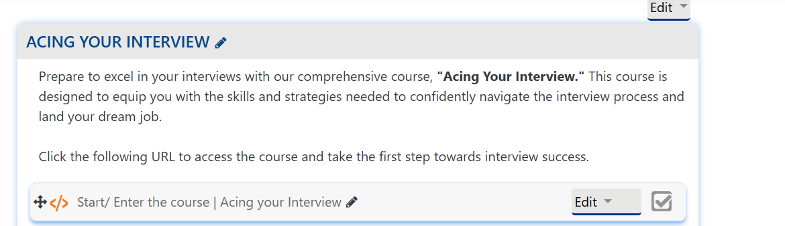

Following steps need to be followed by the student for completing Viva part 2:

- Click on the link under the Acing your interview section (Once you click on the link, you will be redirected to a new page).
- After Login, the following page will appear:

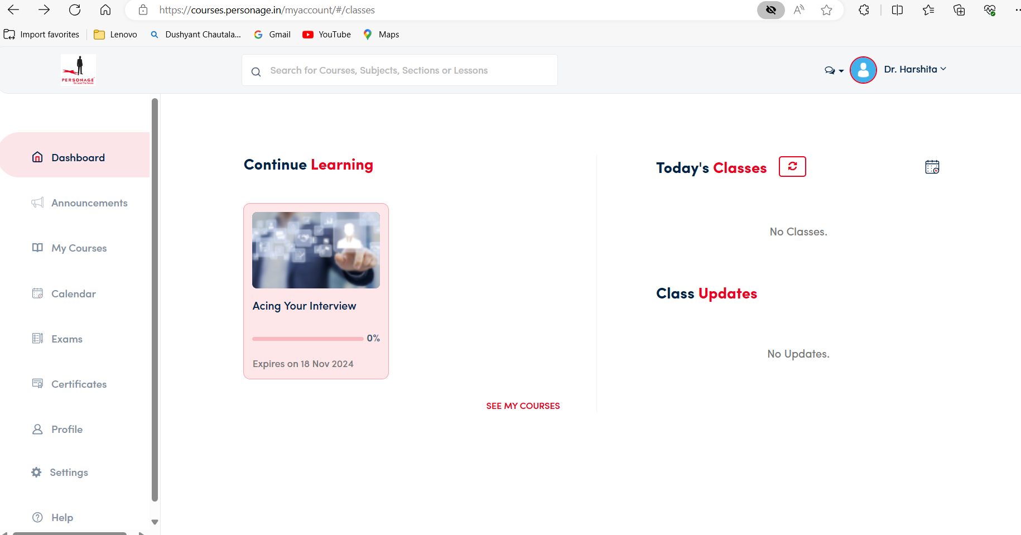

3) Click on my courses:

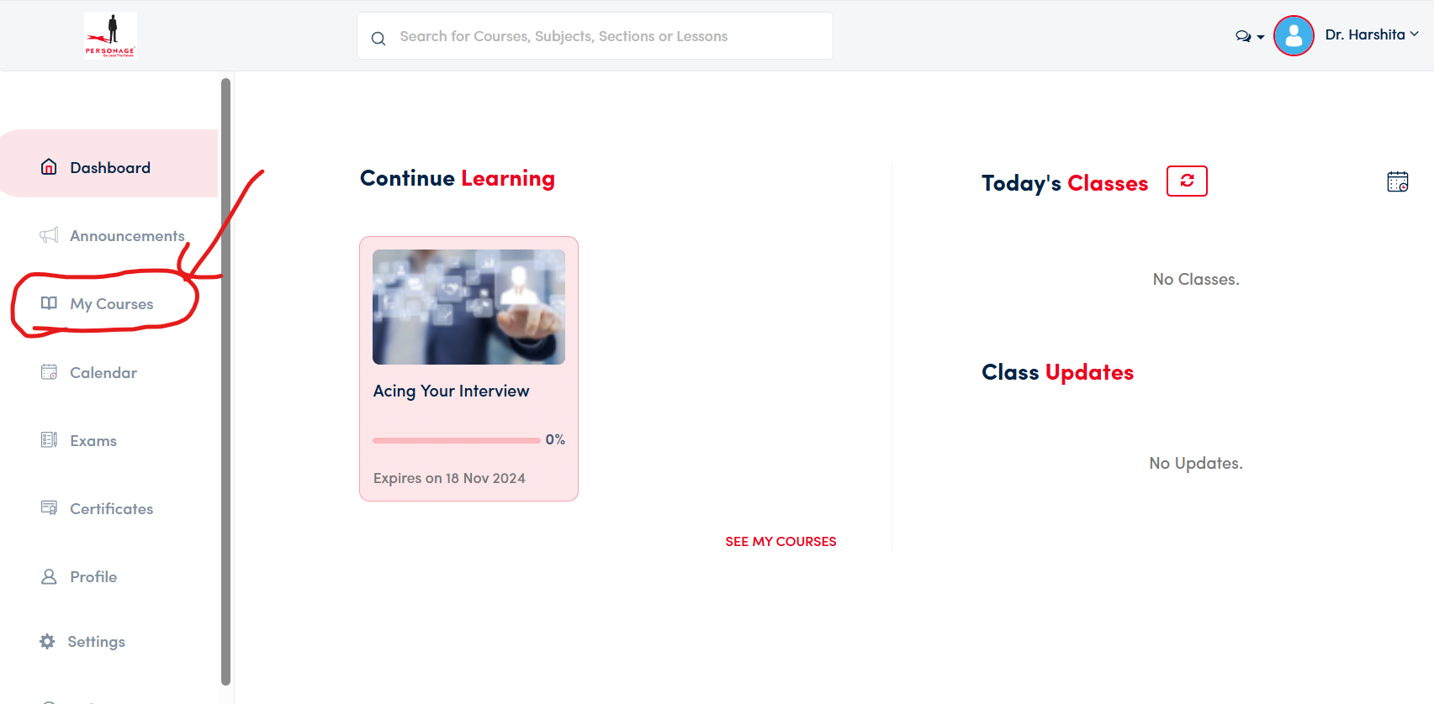

4) Click on Acing your Interview:

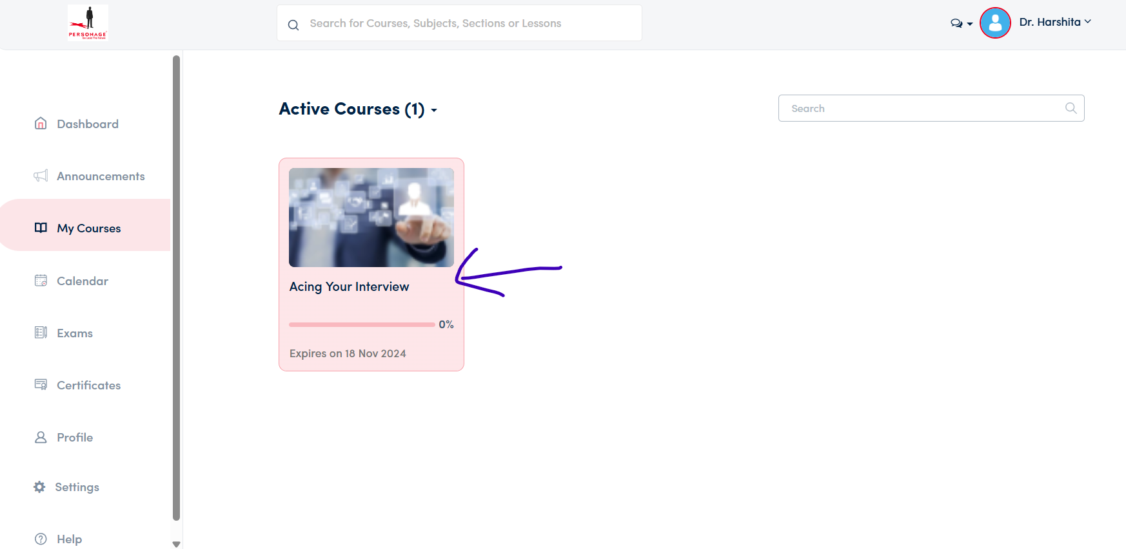

5) Watch all the videos under contents section:

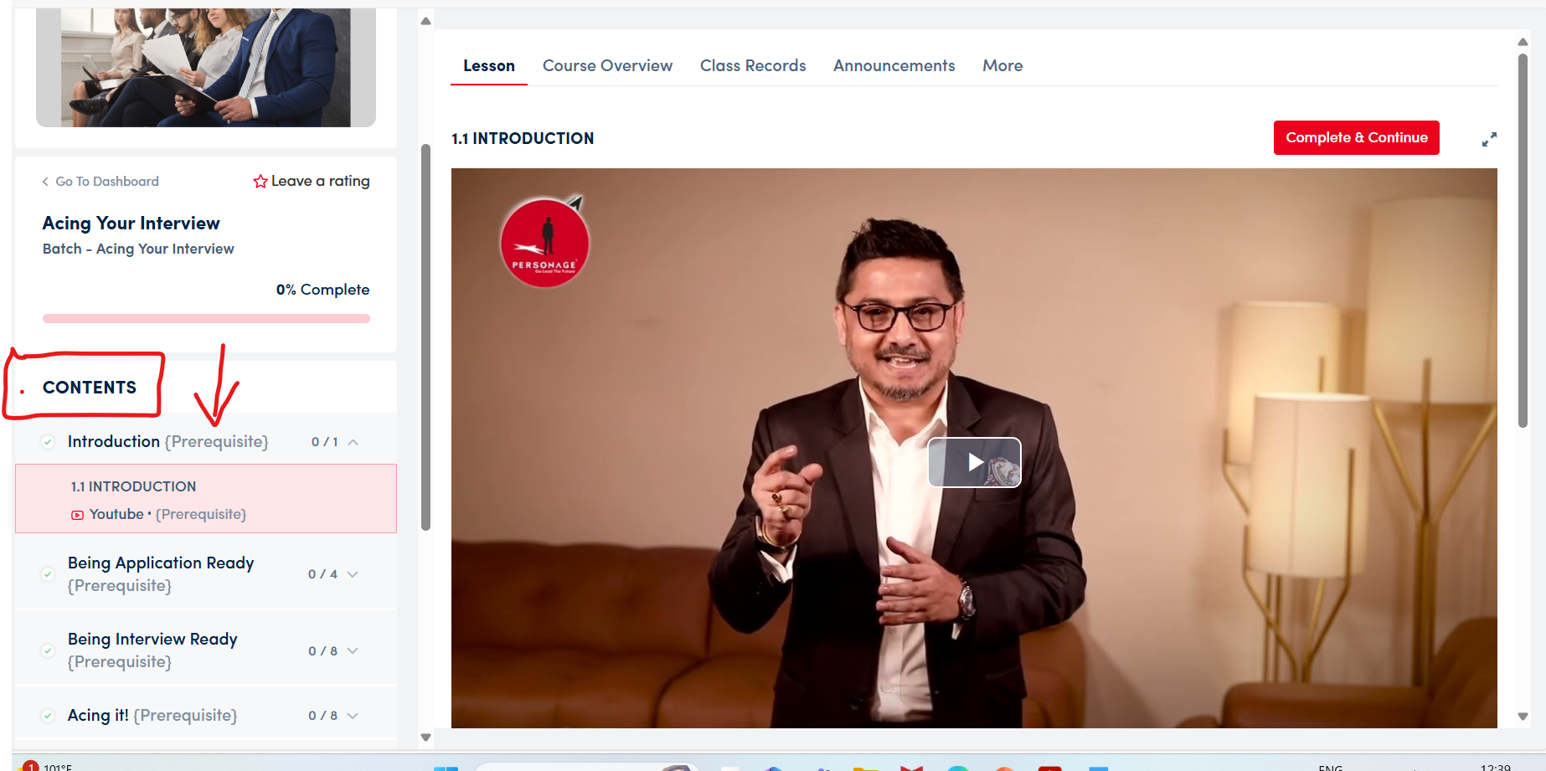

6) After completing all the videos , go back to dashboard and click on “ EXAMS”

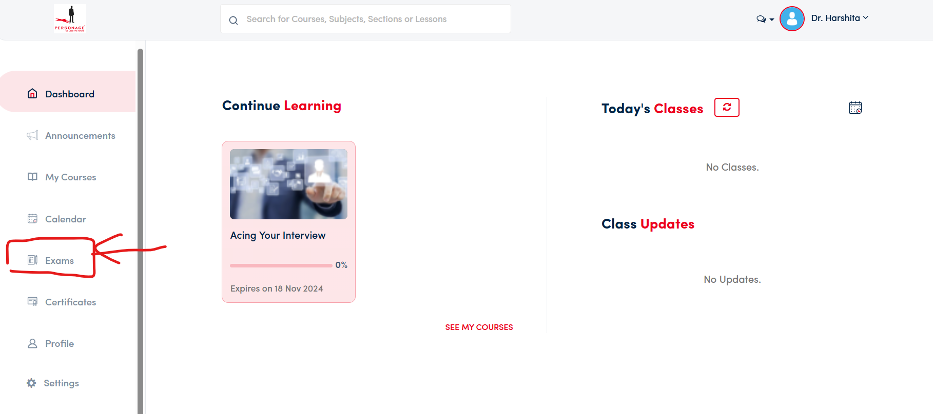

7) Exam page will open as below:
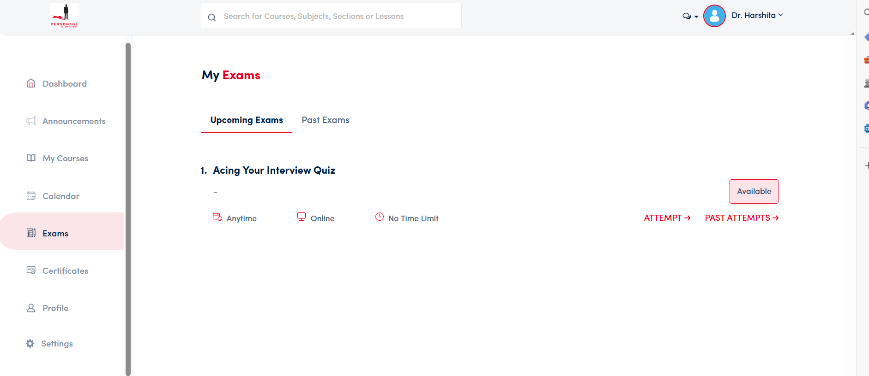

8) Click on attempt:

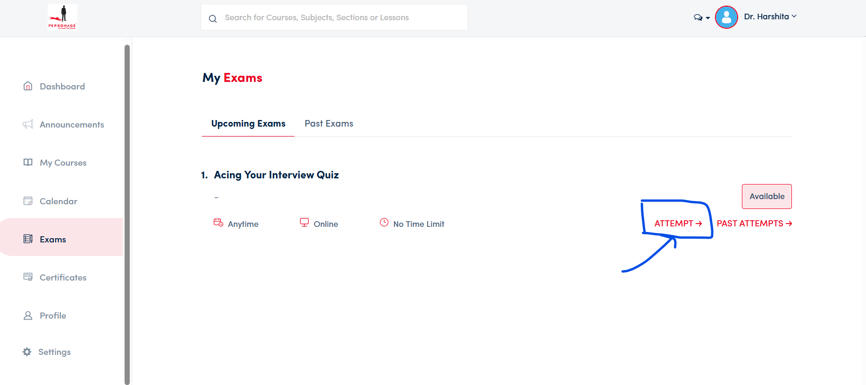

9) Attempt your exam and submit:

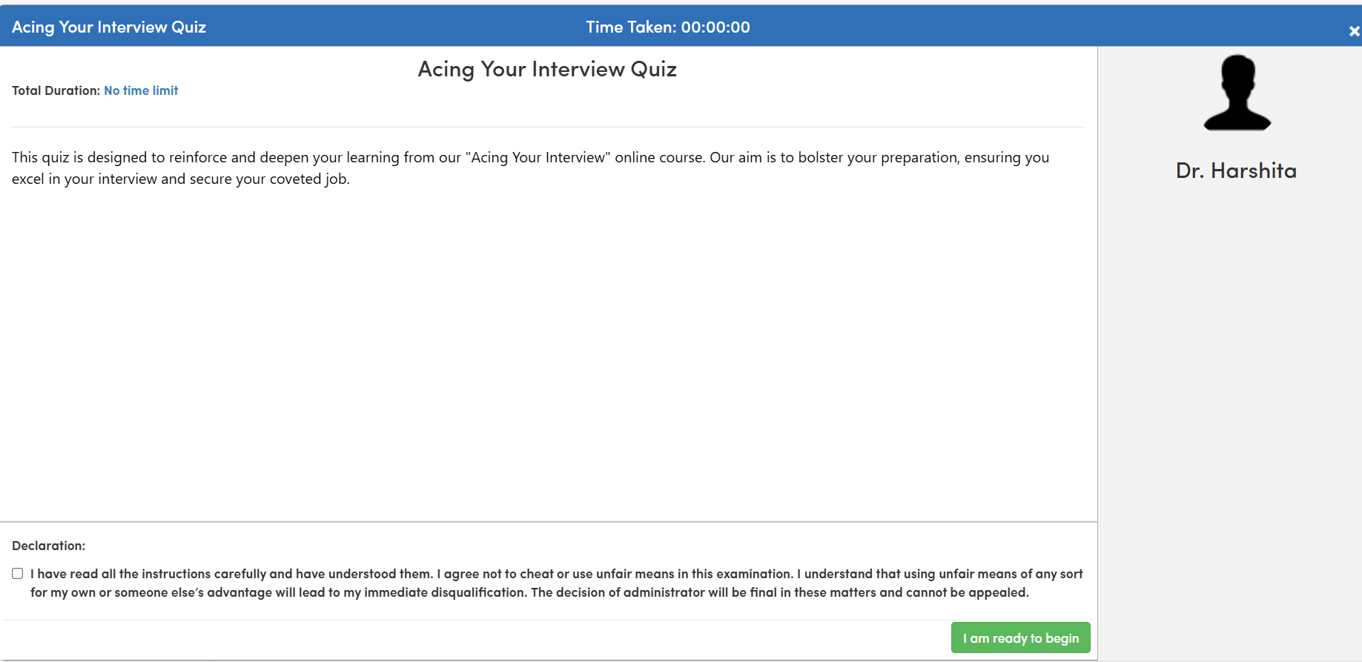

Evaluation Scheme:

Project Report 70
Viva 30 (Part 1: 20 marks, Part 2: 10 marks)
TOTAL of 100

IMPORTANT NOTE
Students must submit all Project Components (Abstract, Guide Resume, Project Report, Plagiarism Report, and Viva Answers).

In case of incomplete details, students will be asked to resubmit all project documents which would lead to delinquency in Academic Completion and Extension Fee.

Plagiarism check would be conducted before evaluation, for all the Project Report submissions. If any report exceeds 15% plagiarism, the same would be rejected and the student will undergo the process of resubmission as per rules. the process of plagiarism checking it will be rejected for resubmission.

